eGo User Guide

Version: 0.0.1
DocCode: E-Tools-ALL-UG-2008-0001
Date:October 18, 2010


www.spreadtrum.com
Important Notice
Copyright Notice
Copyright © 2010, Spreadtrum Communications, Inc. All rights reserved.
Trademarks
Spreadtrum Communications, Inc. and Spreadtrum Communications, Inc.'s products are exclusively owned by Spreadtrum Communications, Inc. References to other companies and their products use trademarks owned by the respective companies and are for reference purpose only.
Warranty Disclaimer
Spreadtrum Communications, Inc. makes no representations or warranties, either expressed or implied, by or with respect to anything in this document, and shall not be liable for any implied warranties of merchantability or fitness for a particular purpose or for any indirect, special or consequential damages.
Confidentiality
The information contained herein (including any attachments) is confidential. The recipient hereby acknowledges the confidentiality of this document, and except for specific purposes, this document shall not be disclosed to any third party.
About This Document

Purpose
The eGo User Guide describes how to use eGo.

Intended Audience

Organization
This document consists of five chapters and is organized as follows.
Chapter | Describes
1 Introduction | File composition and running requirements of eGo.
2 Interface Description | The main interface, toolbar, and status area of eGo.
3 Quick Start | How to start the program, set the parameters, download the software, and quit the program.
4 Basic Operations | Basic operations such as dial-up, sync data and etc.
5 Configure File | Introduce the configure file.

Contents
第1章 Introduction 1-3
1.1 System Overview 1-3
1.2 File Composition 1-3
1.3 Running Requirements 1-3
第2章 Interface Description 2-4
2.1 Main User Interface 2-4
2.2 Toolbar 2-4
2.3 Status Area 2-5
第3章 Quick Start 3-7
3.1 Prepare 3-7
3.2 Running the Program 3-7
3.3 Dial-up 3-7
第4章 Basic Operations 4-9
4.1 Dial-up 4-9
4.1.1 Connect 4-9
4.1.2 Disconnect 4-10
4.2 Data sync 4-11
4.2.1 Short Message (SMS) 4-11
4.2.2 Phone Book (PB) 4-16
4.2.3 Phone book group (PBG) 4-18
4.2.4 Save sync data 4-19
4.2.5 Open sync data 4-19
4.3 Help 4-19
第5章 Configure File 5-20

Figures
Figure 2-1 Main user interface on the disconnected state 5
Figure 2-2 Main user interface on the connected state 6
Figure 2-3 Dial-up user interface 7
Figure 2-4 Sync information user interface 8
Figure 2-5 System menu 8
Figure 2-6 Service menu 9
Figure 2-7 Help menu 9
Figure 2-8 Tray icon menu 9
Figure 2-9 Toolbar 10
Figure 2-10 Status area 10
Figure 3-1 Service menu 11
Figure 3-2 Dial-up user interface 12
Figure 3-3 Try icon menu 12
Figure 4-1 Dial-up user interface 13
Figure 4-2 Dial-up successful interface. 14
Figure 4-3 Preset SMS dialog 15
Figure 4-4 Preset SMS new dialog 16
Figure 4-5 Preset SMS dialog with items. 16
Figure 4-6 Short messages load completely 17
Figure 4-7 SMS dialog 18
Figure 4-8 Select num dialog 18
Figure 4-9 Select preset SMS dialog 19
Figure 4-10 SMS center dialog 20
Figure 4-11 Phone book load completely 21
Figure 4-12 Phone book dialog 21
Figure 4-13 PB Group dialog 23
Tables
Table 1-1 File composition 3
Table 2-1 Dial-up user interface introduction 6
Table 2-2 System menu introduction 7
Table 2-3 Service menu introduction 8
Table 2-4 Help menu introduction 8
Table 2-5 Tray icon menu introduction 8
Table 2-6 Toolbar icons introduction 9
Table 2-7 Columns in the status area 9
Table 5-1 Table 24

Introduction

System Overview
eGo is used to dial-up and sync data such as short message, phone book and phone group.

File Composition
eGo consists of the files described in Table 1-1.
                - File composition
Type | File
*.exe | eGo.exe
*.dll | EtionU.dll  ResEnU.dll  SCIMemoU.dll  SCIMMIPBU.dll  SCIPBGroupU.dll  SciPortU.dll  SCIShortMsgU.dll  SciUartComm.dll
Configuration file | eGo.ini  Channel.ini

Running Requirements
eGo runs on Windows 2000/XP/Vista/Windows7. At least one usable serial port or USB is required.

Interface Description

Main User Interface
If the device is not connected, the main user interface likes Figure 2-1, otherwise likes Figure 2-2.
              - Main user interface on the disconnected state
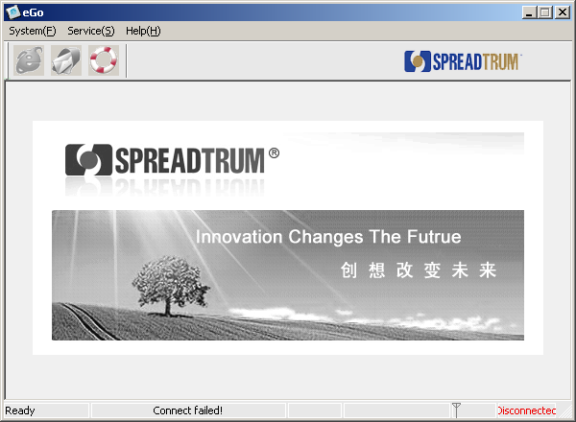
              - Main user interface on the connected state
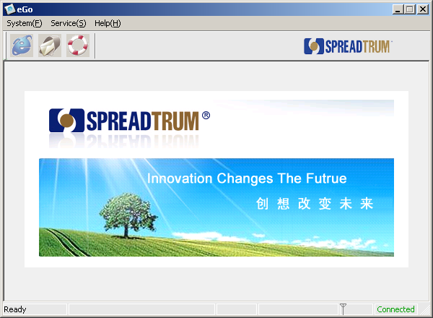

Sub User Interface

Dial-up User Interface
[Dial-up] is showed as Figure 2-1. It is used to dial-up to access Internet.
              - Dial-up user interface
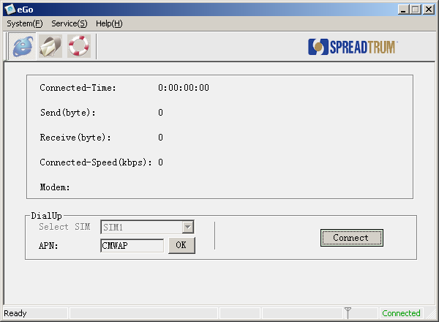
The introduction is showed as Table 2-1.
                - Dial-up user interface introduction
Item | Description
Connected-Time | It shows the time when you dial-up succeed until you disconnect.
Send(byte) | It shows the quantity of data sent since you dial-up succeeded.
Received(Byte) | It shows the quantity of data received since you dial-up succeeded.
Connected-Speed(kbps) | It shows the speed of data stream.
Modem | Modem name.

Sync Information User Interface
[Sync Information] provides a set of operation for short message and phone book. It is showed as Figure 2-1.

              - Sync information user interface
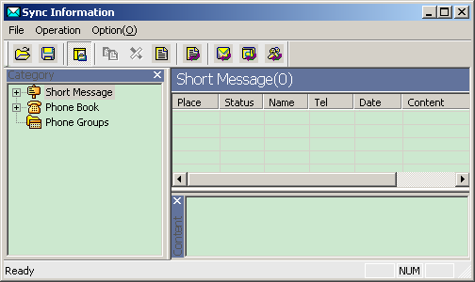

Menu

System
[System] menu showed as Figure 2-1 and its items are described as Table 2-1.
              - System menu
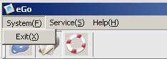
                - System menu introduction
Item | Description
Exit | Exit the program.

Service
[Service] menu showed as Figure 2-1 and its items are described as Table 2-1.
              - Service menu
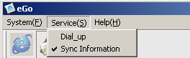
                - Service menu introduction
Item | Description
Dial-up | Dial-up to access Internet
Sync Information | Sync Information

Help
[Help] menu showed as Figure 2-1 and its items are described as Table 2-1.
              - Help menu
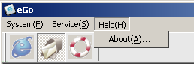
                - Help menu introduction
Item | Description
About | Display version information dialog

Tray Icon Right Click Menu
[Tray Icon Menu] menu showed as Figure 2-1 and its items are described as Table 2-1.
              - Tray icon menu
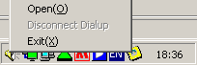
                - Tray icon menu introduction
Item | Description
Open | Show the Main user interface on the desktop
Disconnect Dial-up | Disconnect the Internet
Exit | Exit the program.

Toolbar
Toolbar is showed as Figure 2-1 and its items are described as Table 2-1.
              - Toolbar
                - Toolbar icons introduction
Icon | Description
 | Show dial-up user interface
 | Show sync information use interface
 | Show version information dialog

Status Bar
The status bar is showed as Figure 2-1 and its items are described as Table 2-1.
              - Status area
                - Columns in the status area
Column | Description
a | Operation tips.
b | Runtime information.
c | Signal
d | Connect state

Quick Start

Prepare
First, make sure that modem driver was installed on your PC, and it works normally.
Second, make sure that mobile phone was connected with your PC by USB line.。
Note:
Make sure that there existed at least one SIM card in your mobile phone; otherwise eGo can not connect with the mobile phone.

Running the Program
Click the eGo.exe file in the folder of eGo tool installed. eGo will connect the mobile phone automatically. When connected, the yellow icon will be showed on the system bar.

Dial-up
Here will introduce the shortcut steps to dial-up access Internet. The detailed steps can be found in.
Click menu “Service”-> “Dial-up”, see Figure 3-1:
              - Service menu
Or click the button  on the tool bar to enter the “Dial-up” interface, see Figure 3-2:
              - Dial-up user interface
Click the button “Connect” to dial-up. At the same time, Dial-up process will be showed under this interface.
Note:
There will be many dialogs in the dial-up process, please follow them.

When dial-up connected, the icon will be showed on the right-bottom corner of your PC screen. Click the minimized button and the tool will be showed as a green icon on the right-bottom corner of your PC screen.
When you want to disconnect the internet, you can right click the icon and show the menu, see Figure 3-3, and then click “Disconnect”. Click the “Open” on this menu, and the tool interface will show on the desktop. Click “exit” on this menu, you can close and exit the tool.
              - Try icon menu
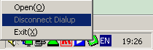

Basic Operations

Dial-up

Connect
[Dial-up] operation steps are as following:
Click “Connect” button to dial-up, see Error: Reference source not found.
              - Dial-up user interface
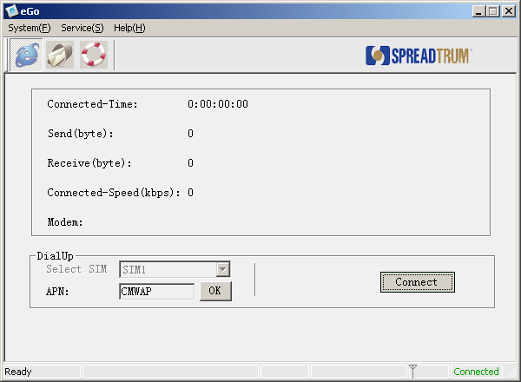
When connect successfully, the “Connect” button changes to “Disconnect” button, at the same time, the icon on the system tool bar changes green. “Connect time”, “Send data” and “Receive data” will be updated in real time, see Figure 4-2:
              - Dial-up successful interface.
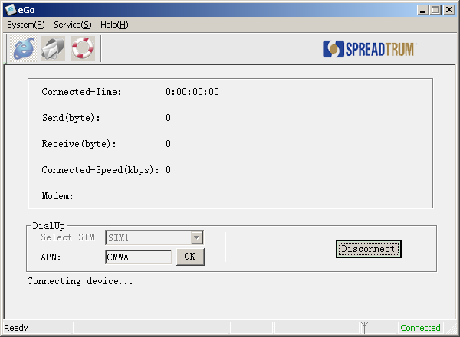
After connected, you can click the minimized button to make the tool show as an icon on the system bar. It will be convenient for surfing Internet. You can right click the icon, and a menu will be showed, and then you can select “Open” to display the tool on the desktop again.

Disconnect
There are tow ways to disconnect the Internet:
- Click the “Disconnect” button to disconnect the Internet.
- Right click the iconon the system bar and show the menu, and select “Disconnect” item to disconnect the Internet.

Data sync
Click the icon on the toolbar to show the data-sync user interface, see 2.2.2 Figure 2-1.

Short Message (SMS)
[SMS]Supply the following services:
- Preset short message
- Read short message
- Create new short message
- Edit short message
- Send short message
- Reply short message
- Forward short message
- Delete short message
- Query and set the number of SMS center
Detailed functions are as bellowing.
  - Reset short message
Select the menu [Option] -> [SMS ]-> [Preset SMS], or select the SMS on the left tree view and right click the right list view to show the menu and select [Preset SMS], and then the preset SMS dialog is showed as Figure 4-1:
              - Preset SMS dialog
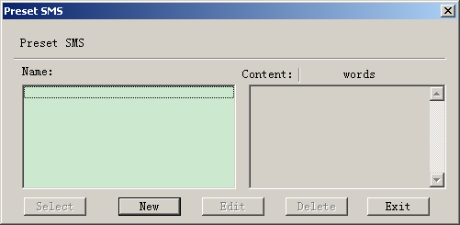
1）Click “New” button, the dialog changes as Figure 4-2:

              - Preset SMS new dialog
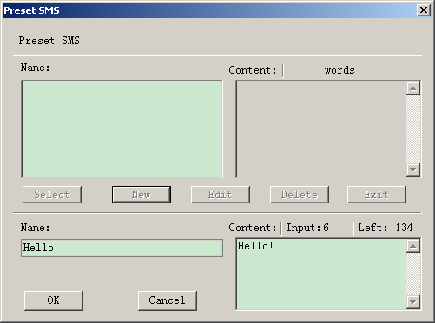
2）Input the information in the “Name” and “Content” edit box. And then click “OK” button to preset a short message, and then the interface is showed as Figure 4-3.
              - Preset SMS dialog with items.
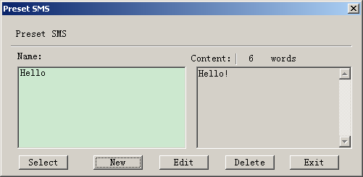
Note:
- You can only input 140 Latin characters or 70 other words (e.g. Chinese words).
- You can create multi preset-SMS
- When you select a preset-SMS, you can edit its content but not modify its name.
- [Select] button is invalid in this service.
- All preset-SMS are stored in the file “PresetSMS.dat”. If you delete this file, all preset-SMS are deleted too.
  - Read short message
Select the “Short Message” on the left tree view, and then click the icon to load short messages, or select the menu [Option] -> [Load] -> [SMS]. And the tool will load short messages from the mobile phone. The load process will be showed in the statues bar. After loading complete, a dialog will be showed to tell you loading complete. All short messages loaded from mobile phone will showed in the right list view as Figure 4-4. When you click one short message and its content will be showed in the “content” view.
              - Short messages load completely
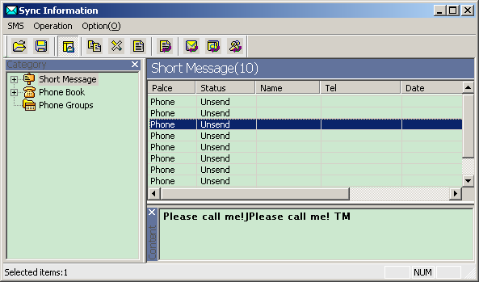
  - Create new short message
Right click the right list view and show the menu, and select [New] to show create new short message dialog as Figure 4-5:
              - SMS dialog
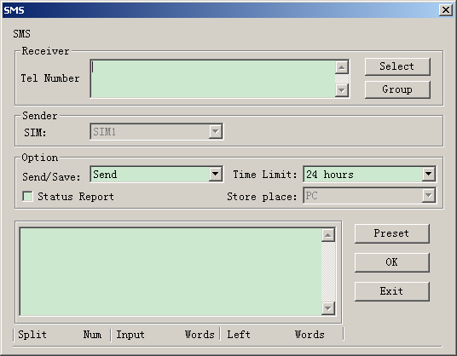
- Input the receiver phone number. You can input multi phone number and separate them with “;”. If you have load phone book from mobile phone, you can click the “Select” button to select phone number and the interface is showed as Figure 4-6.
              - Select num dialog
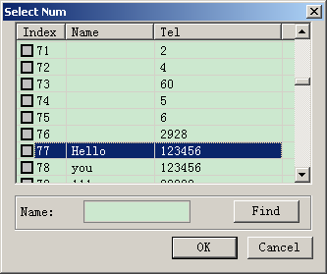
- Input the short message content. If you have preset-SMS, you can click “Preset” button to select preset short messages and the interface is showed as Figure 4-7.
              - Select preset SMS dialog
- Set the “Send/Save”, “Time Limit”, “Status report” options if necessary。
- If you have two SIM cards in the mobile phone, you need set the sender using which SIM card to send the SMS.
- Click “OK” button to send or save the current short message.

  - Edit short message
(1) Double click the short message in the right list view or right click the short message to show the menu, and select [Edit]. And then will show the SMS dialog.
（2）You can modify the short message as the “Create new short message” sector.
  - Send short message
Select the “Unsent” short message in the right list view, and right click to show the menu, and then select [Send] item to send this short message. When you create a new short message, you can click the “OK” button to send the new short message.
  - Reply short message
Select the short message in the right list view, and right click to show the menu, and then select [Reply] item
Note:
You can only reply the short messages in the “Inbox”.

  - Forward short message
Select the short message in the right list view, and right click to show the menu, and then select [Forward] item

  - Delete short message
Select the short messages in the right list view, and right click to show the menu, and then select [Delete] item.

  - Query and set the number of SMS cent
Select menu [Option] -> [SMS] -> [Center Number], and show a dialog as Figure 4-8:
              - SMS center dialog
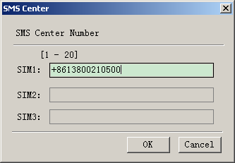
eGo will query the center number from mobile phone and display them. If you want reset them, modify the number and click “OK” button.
Note:
SMS center number is provided by your mobile operator.
Max length is 20.
Valid characters are “0”-“9” and “+#*abcABC”.

Phone Book (PB)
[PB]Supply the following services:
  - Read phone book
  - Create new phone book
  - Edit phone book
  - Delete phone book
  - Export VCARD
  - Import VCARD
Detailed functions are as bellowing
  - Read phone book
Select the “Phone book” on the left tree view, and then click the icon to load phone book, or select the menu [Option] -> [Load] -> [PhoneBook]. And the tool will load phone book from the mobile phone. The load process will be showed in the statues bar. After loading complete, a dialog will be showed to tell you loading complete. All phone book items loaded from mobile phone will showed in the right list view as Figure 4-1.
              - Phone book load completely
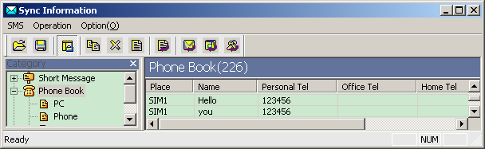

  - Create new phone book
Right click the right list view and show the menu, and select [New] to show create new phone book dialog as Figure 4-2:
              - Phone book dialog
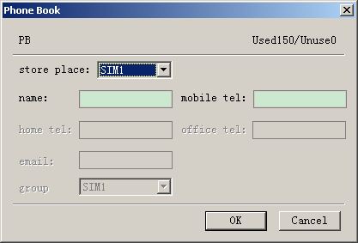
  - Select store place
  - Input the content as instruct of the interface
  - Click “OK” button to save the phone book item to the store place.

  - Edit phone book
(1) Double click the phone book item in the right list view or right click it to show the menu, and select [Edit]. And then will show the “Phone Book” dialog.
（2）You can modify the phone book item as the “Create new phone book” sector.

  - Delete phone book
Select the phone book items in the right list view, and right click to show the menu, and then select [Delete] item.

  - Export VCARD
Select the phone book items in the right list view, and right click to show the menu, and then select [Export VCard] item, and then will show a dialog to select a folder to save them.
Note:
The VCARD file name is same as the phone name.

  - Import VCARD
Right click the right list view to show the menu, and then select [Import VCard] item, and then will show a dialog to select VCARD files.

Phone book group (PBG)
  - Read phone book group
Select the “Phone book group” on the left tree view, and then click the icon to load phone book group, or select the menu [Option] -> [Load] -> [PhoneBook Group]. And the tool will load phone book group from the mobile phone. The load process will be showed in the statues bar. After loading complete, a dialog will be showed to tell you loading complete. All phone book group items loaded from mobile phone will showed in the right list view.
  - Edit phone book group
(1) Select the “Phone Groups” on the left tree view. Double click the phone book group item in the right list view or right click it to show the menu, and select [Edit]. And then will show the “PB Group” dialog as Figure 4-1.
              - PB Group dialog
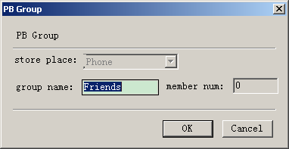
（2）Modify the group name.
Note:
You can only modify the group name and can not add or delete group.
You modify the phone members of one group by “Edit phone book”.

Save sync data
Select menu [File] -> [Save]. It will save the sync data to your PC.
Note:
This will save the SMS, PB and PB Group data to your PC.
Before saving the sync data, you must execute the sync operation for SMS, PB or PB Group.

Open sync data
Select menu [File] -> [Open]. It will open the sync data from your PC.

Help
Click the icon on the tool bar, you will see the version of eGo.

Configure File
“EGO.ini” is eGo configure file. It can be found in the folder of eGo installed. Its content is as following:

[Log]
Enable=1
[Net]
DialTime=1
DialNum=3
[PS Depatch]
Depatch=0
[Lang]
lang=0
[Setting]
manual = 0
port = 12
baud = 115200

[DeviceBaudRate]
BaudRate = 115200

[DeviceCount]
Count=2

[DeviceGeneral1]
Device=SCI USBModem
[DeviceMux1]
DeviceSerCount=2
DeviceSer1=SCI VSerial1
DeviceSer2=SCI VSerial2
DeviceModCount=2
DeviceMod1=SCI VModem1
DeviceMod2=SCI VModem2

[DeviceGeneral2]
Device=SPRD CMCC Modem
[DeviceMux2]
DeviceSerCount=2
DeviceSer1=SPRD CMCC AT Interface1
DeviceSer2=SPRD CMCC AT Interface2
DeviceModCount=2
DeviceMod1=SPRD CMCC Modem
DeviceMod2=SPRD CMCC MMS

Parameters are introduced as Table 5-1:
                - Table
Sector | Description
Log | Enable = 1 means to generate “EGO_com.log” file to save the data communicated tool and mobile phone.  Enable = 0 not to generate the log file.
Net | DialTim = 1 means to redial after 1 second if dial-up failed.  DialNum = 3 means to redial 3 times if dial-up failed.
PS Depatch | Depatch = 1 means to PS Depatch
Lang | Lang=0 means the UI text is Chinese.  Lang=1 means the UI text is English.
Setting | Manual = 1 means the port and baud set is valid, and eGo will open this port.
DeviceBaudRate | BaudRate = 115200 means eGo will use the baud rate to communicate.
DeviceCount | Count=2 means the tool support two category devices. When the tool can not connect the first device, it will try to connect the next until succeed or all fail.
DeviceGeneralX | Device=SCI USBModem means the device name if not use MUX driver.
DeviceMuxX | This is for MUX driver.  DeviceSerCount = 2 means the MUX driver will generate to two virtual AT ports.  DeviceSer1and DeviceSer2 are the name of the two AT ports DeviceModCount = means the MUX driver will generate to two virtual modem ports.  DeviceMod1和DeviceMod2 are the name of the two modem ports

